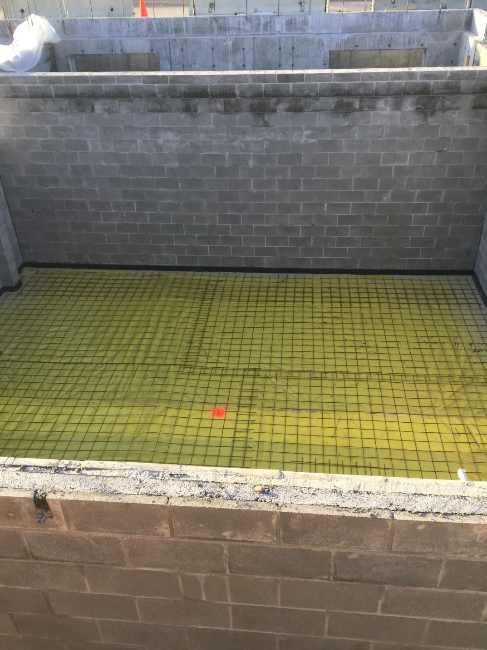
With all the interior block walls in place, a basement room is ready for the floor to be poured. Rigid insulation, vapor barrier, and reinforcing are in place in preparation for the concrete to be poured.

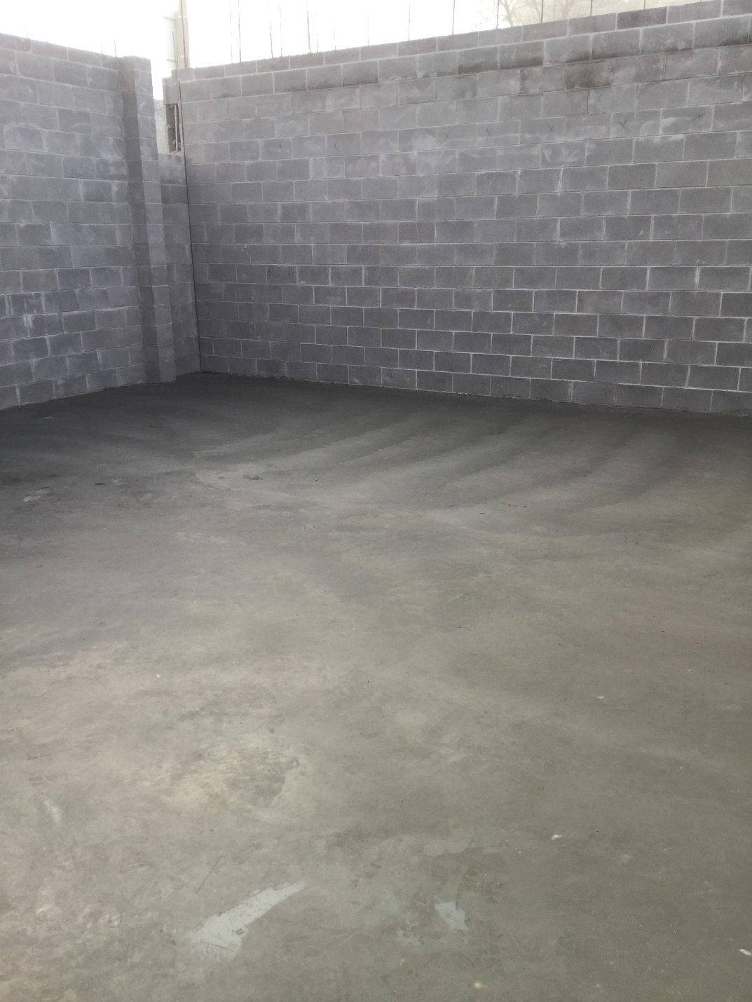

The finished floor troweled to a smooth finish.

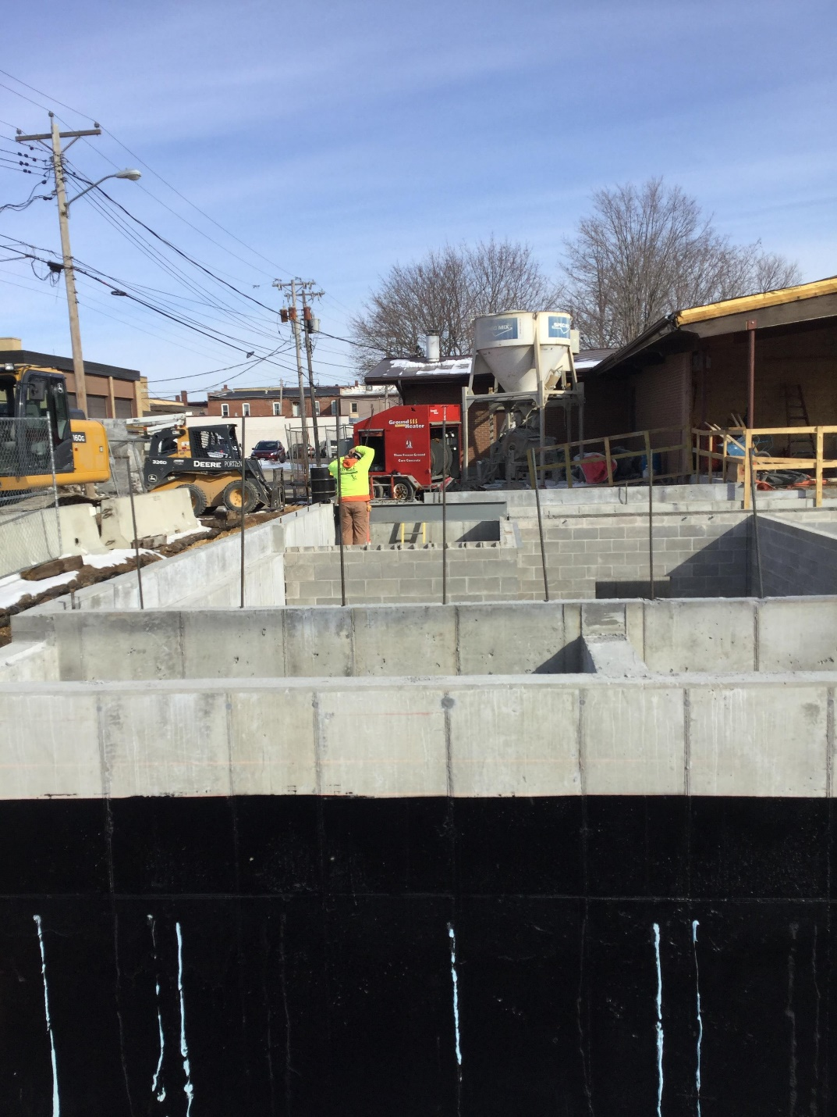
The exterior basement walls were prepared for backfilling in three ways. First, a water proofing material is applied to the walls (this photo shows the black waterproofing). Second, rigid foam insulation is glued to the walls (this photo shows the adhesive applied). Finally, a “drainage mat” is applied over the insulation. The drainage mat directs any water away from the wall and to the drainage pipes at the base of the walls.
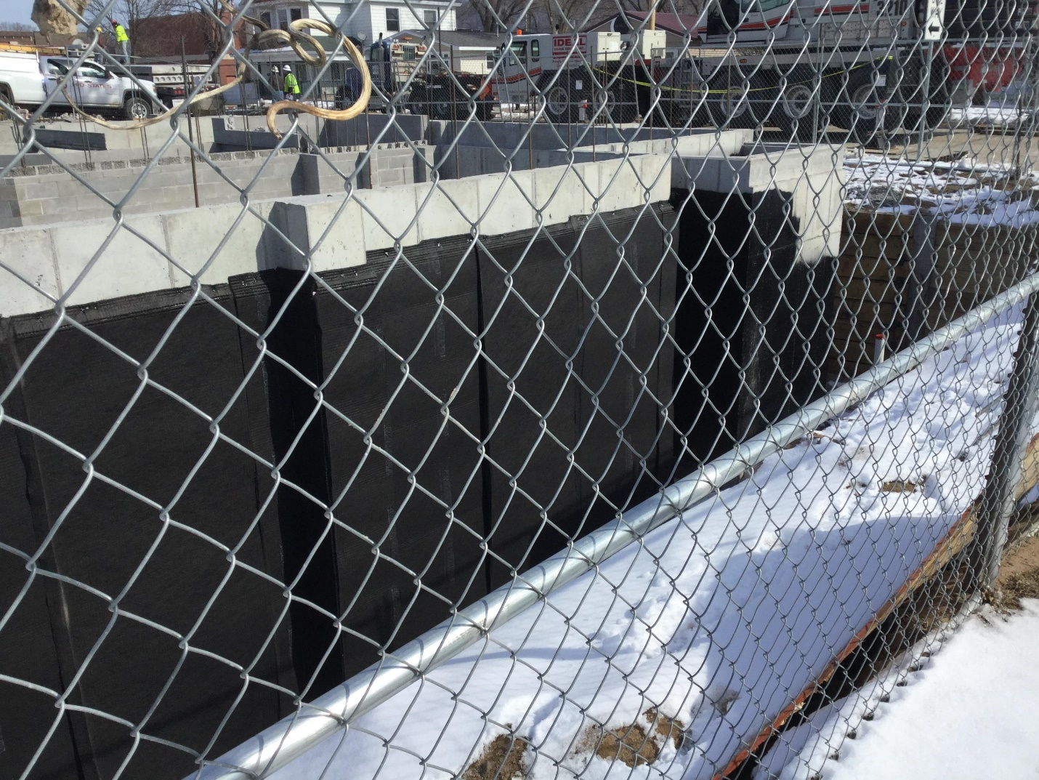
This photo shows the “drainage mat” applied over the rigid insulation on the basement walls.

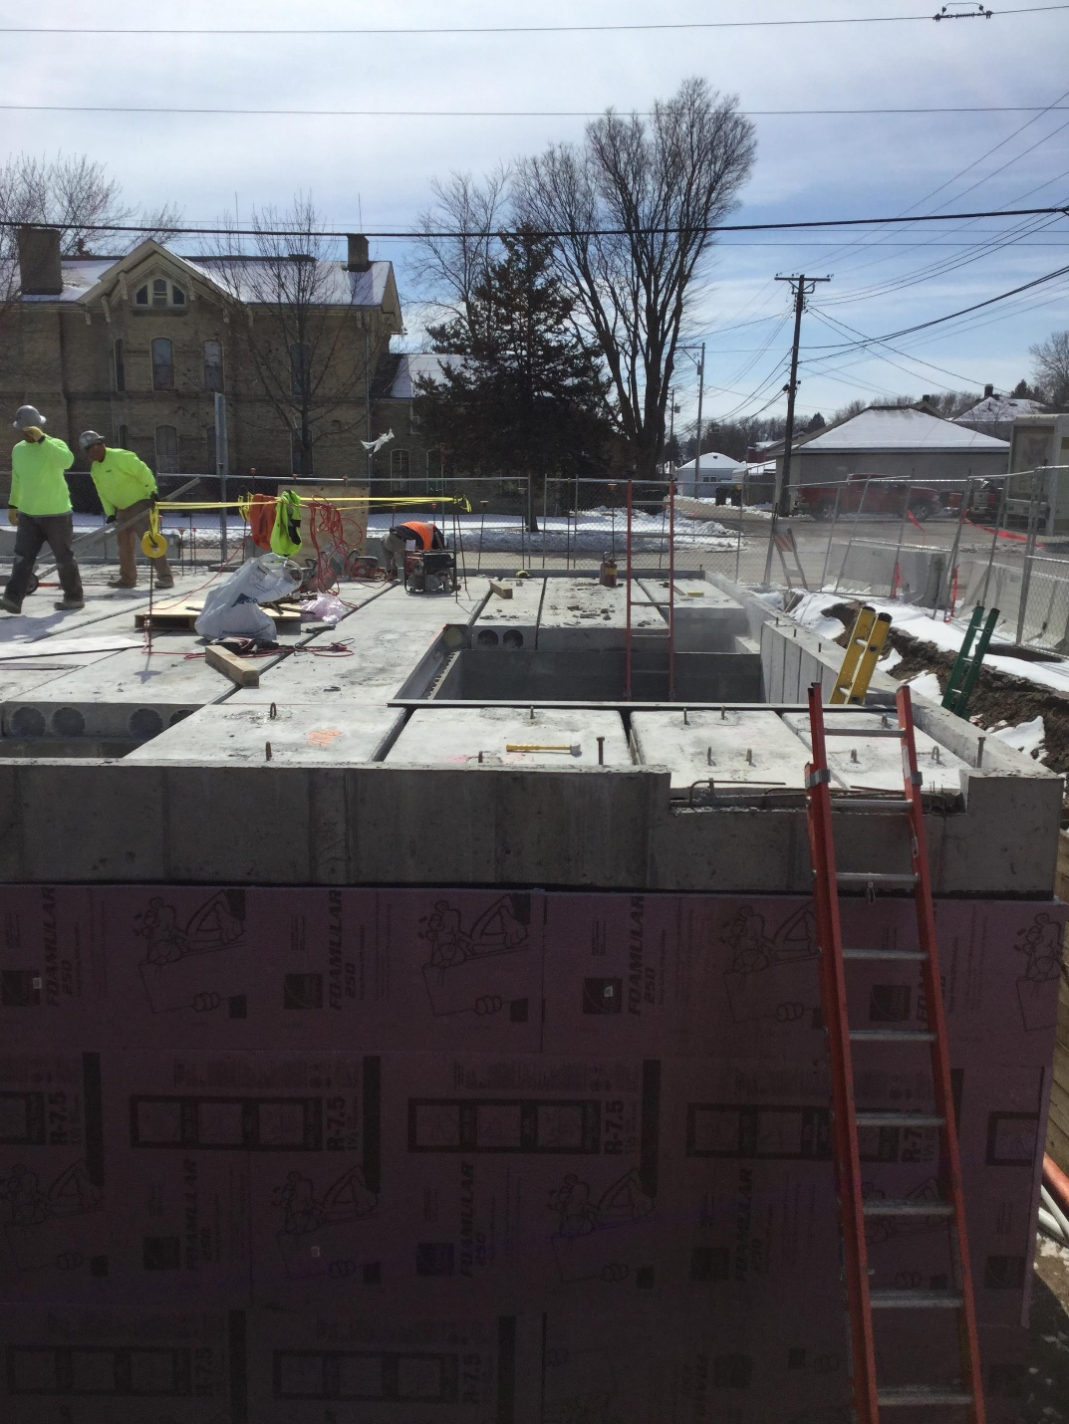
The precast, hollow-core, concrete planking begin to get set into place to cap off the basement and create a solid floor for the first floor of the library. Each piece has its unique place in the floor design. This photo also shows the second phase of the exterior basement walls – the rigid foam insulation.

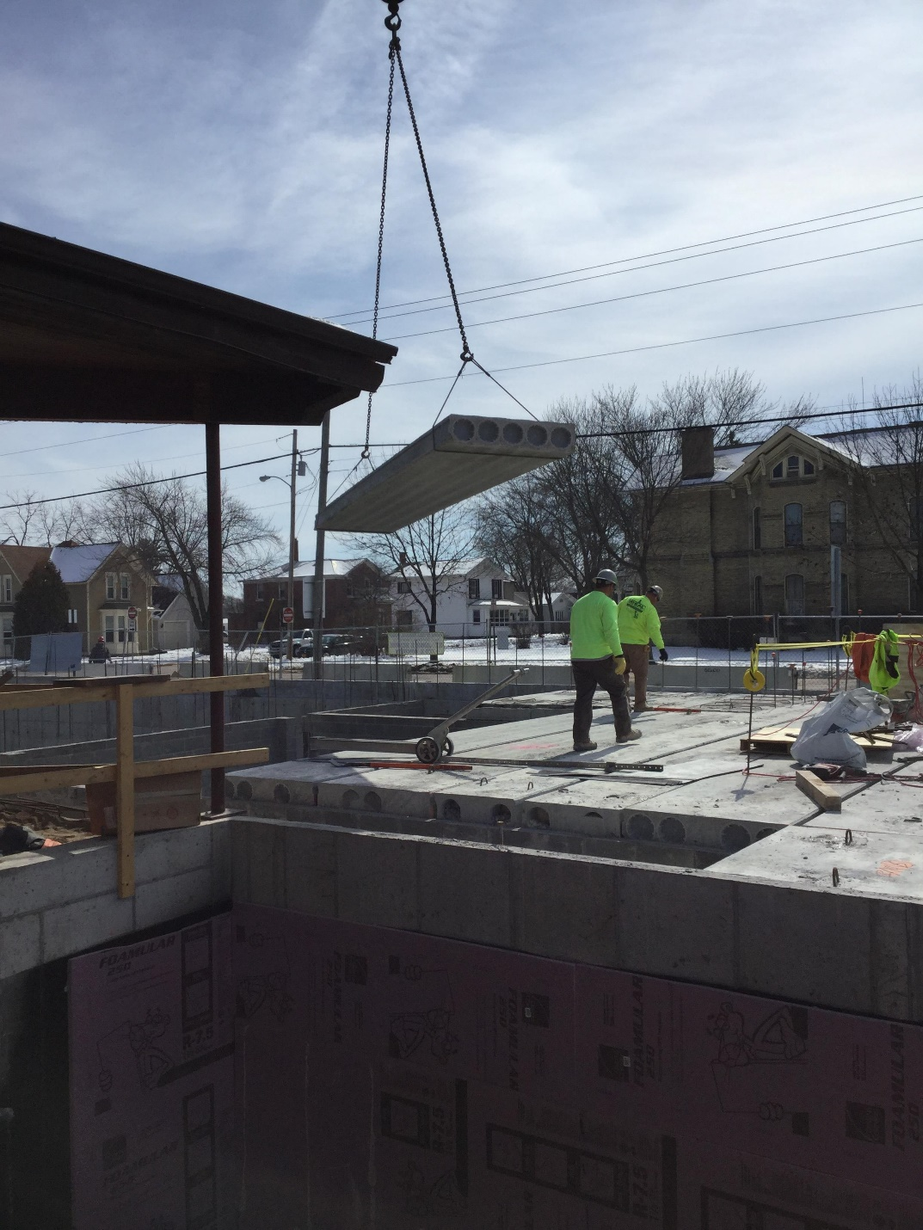

Because of the size and weight of the planks, they must be craned into place. Each plank is ten to twelve inches thick. The sizes and shapes of the planks vary based upon their specific location in the floor. It is a jig saw puzzle but one where the pieces are placed with a crane and grouted in place.
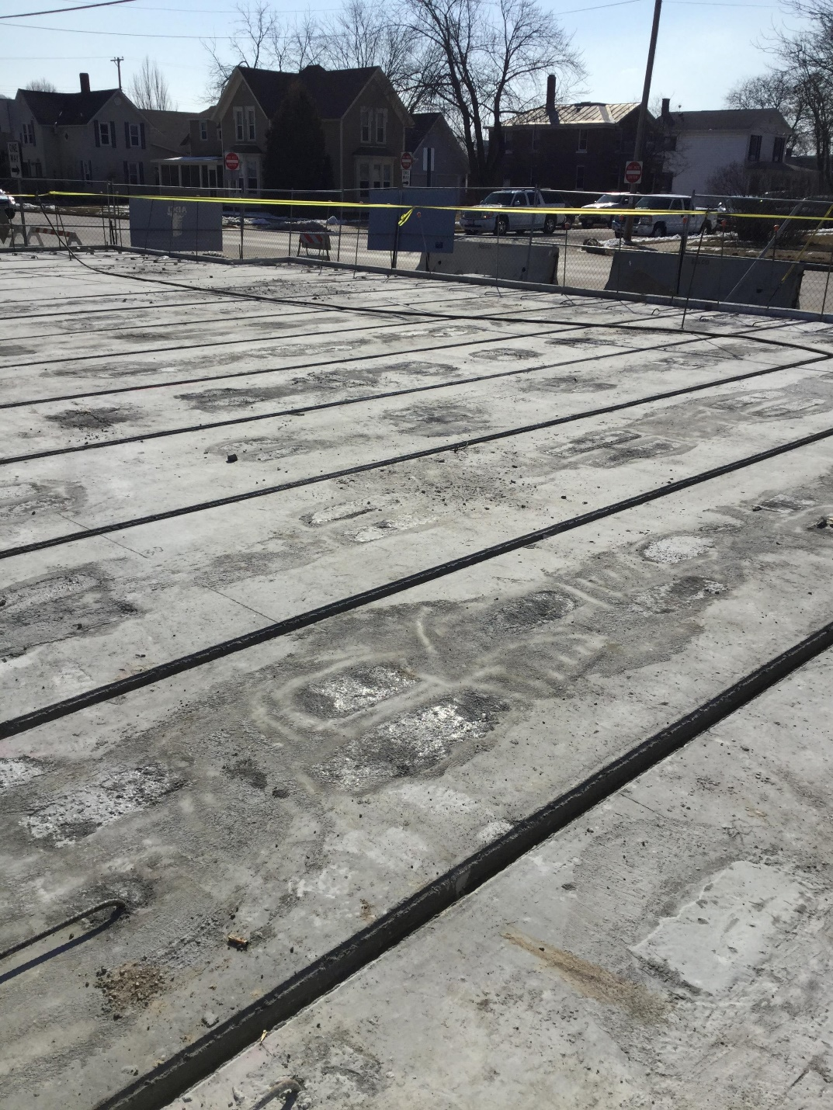
The concrete planks are all set in place in preparation for grouting. The longest planks are up to 36 feet in length.

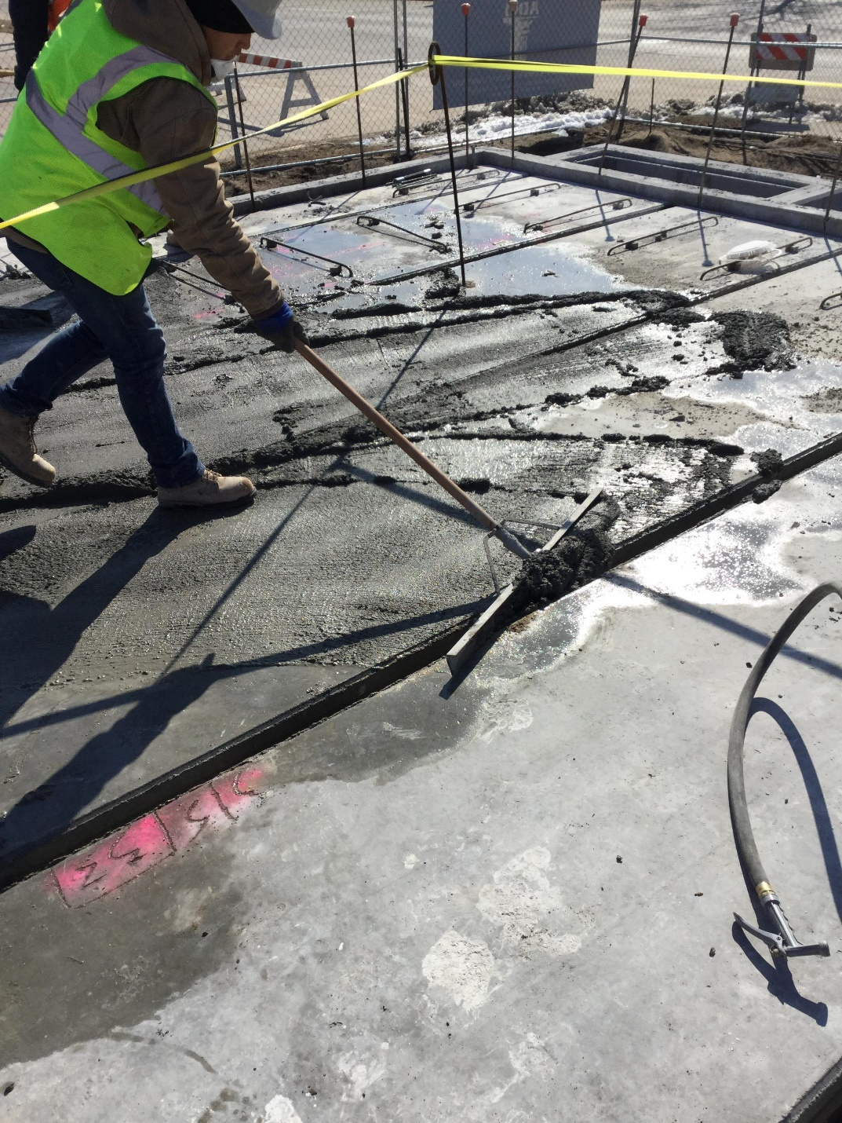

The gaps between the concrete planks are filled with grout. In addition to the grouting and the weight of the planks, the planks are further secured by the exposed rebar from the existing walls being tied into the planks. On top of all of this, a thin slab will be poured further locking together the walls and planks. The basement and especially the multi-purpose safe room will be dry, secure, usable, and safe. The first floor of the library will now be built be on this solid foundation.

